INSTRUCTIONS
Please read the instructions carefully before doing the questions.
• You are NOT allowed to use any other materials. You are NOT allowed to use any device to share data with others.
• You must use an IDE such as Visual Studio 2019 or later, .NET 8 or later and Microsoft SQL Server 2016 or later as your development tools.
IMPORTANT – Before starting your solution, you MUST complete the following steps:
1. You are given a database script (.sql file) in Zip file. Execute the script before doing questions.
2. You must use the given solution.
3. You are not allowed to add any more libraries via NuGet Package Manager into the given solution.
4. Just one of above requirements is violated, your work will be considered as invalid.
5. On completion, submit the whole solution folder.
6. Before submitting, you can delete the folder [bin] in each project to reduce the size of the solution, to fit the requirements of PEA_Client.
QUESTION 1
You are tasked with implementing several classes, interfaces and delegates in C# to model a system that manages a list of members, including students and teachers. You need to follow the provided structure and ensure that the main program (given Main method) runs correctly.
SPECIFIC REQUIREMENTS
1. Delegate Notify
Define a delegate named Notify that takes no parameters and returns no value.
2. Interface IItem
The IItem interface contains the following method: void Display() displays the information of the item.
3. Interface ICustomList
The ICustomList interface contains the following methods: void Add(IItem item) adds an item to the list. void DisplayList() displays all the items in the list.
4. Class Student
Implements the IItem interface. See Figure 1 for the format of the information displayed when implementing the Display function.
Properties:
int Id
string? Name
DateOnly Dob
Write an appropriate constructor to initialize the properties.
5. Class Teacher
Implements the IItem interface. See Figure 1 for the format of the information displayed when implementing the Display function.
Properties:
int Id
string? Name
string? Skill
Write an appropriate constructor to initialize the properties.
6. Class MemberList
Implements the ICustomList interface.
Properties:
int MaximumNumberOfMember
Write an appropriate constructor to initialize the properties.
Methods:
void Add(IItem item):
Adds the item to the list. If the list reaches its maximum capacity, the OnFullOfMember event, which uses the Notify delegate, will be triggered.
event Notify? OnFullOfMember
You should write your own Main method to test all the functionality you have implemented.
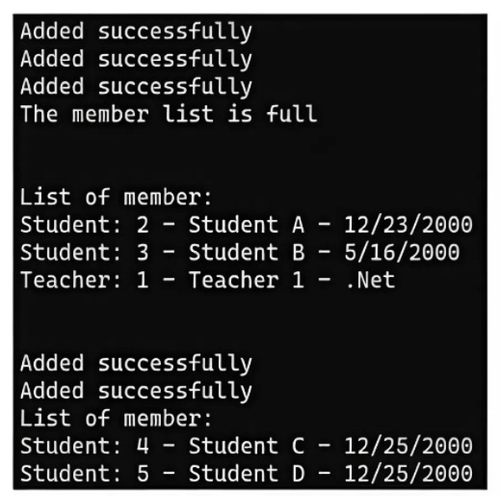
Figure 1. Output Screenshot.
QUESTION 2
You are required to develop a WPF (.NET) application that interacts with a SQL Server database using Entity Framework (EF). The application will allow users to view, search, and edit book records in a database.
DATABASE DETAILS
The Books table in the SQL Server database has the following structure:
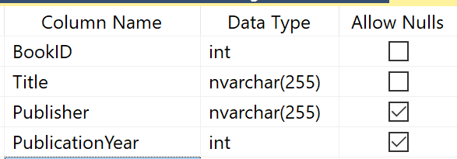
FUNCTIONAL REQUIREMENTS
1. Display Books
The application should display a list of all books from the Books table. The list must include the following columns: BookID, Title, Publisher, and PublicationYear. See Figure 1 below.
2. Search Books
Implement a search feature that allows the user to search for books by Title and/or Publisher. The search functionality should support:
- Searching by partial or full matches for Title and Publisher (Title and Publisher contain the required phrase)
- Users can provide any combination of these search criteria to filter the books: Both Title and Publisher, only Title or only Publisher.
3. Edit Book Information
When the user selects a book from the list, the details of the selected book should be loaded into a separate set of input controls.
The user can edit the book's Title, Publisher, and PublicationYear fields. The BookId field should not be editable.
After editing, the user can click a Save button to update the information in the database. Changes should be saved back to the database, and the list should refresh to reflect the updates.
4. Input Validation
Ensure that the Title, Publisher, and PublicationYear fields are not empty when editing.
Validate that the PublicationYear is a valid integer when editing.
USER INTERFACE REQUIREMENTS
The application should consist of a single MainWindow with the following components:
A DataGrid to display the list of books.
Search Section: Input fields (TextBox) for Title, Publisher, and PublicationYear, along with a Search button to filter the book list based on search criteria.
Edit Section: A separate set of input fields (TextBox) for Title, Publisher, and PublicationYear, along with a Save button to allow users to edit and save the selected book's information.
The BookID should be displayed but not editable.
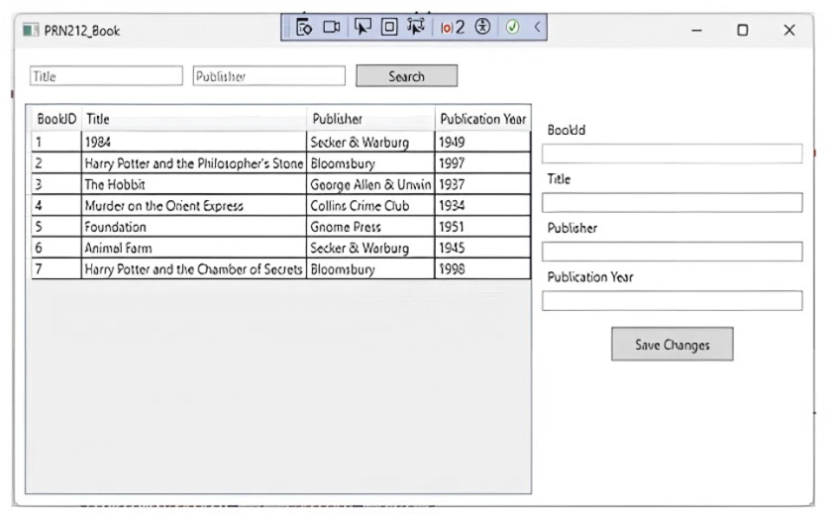
Figure 2. The required WPF Window.
SUBMISSION REQUIREMENTS
Ensure that the database connection string is adjustable through appsettings.json (otherwise your post will get 0 points)

